Rymbayeva Anelya, 2 course, Lab1 – IT Infrastructure and Networks

1. Click S1 and then click the CLI tab. Enter the correct command to configure the hostname as S1.

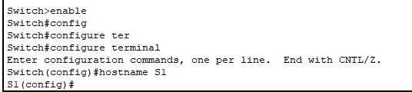

1. Use cisco for the console password.

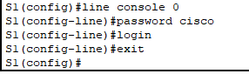

1. Use class for the privileged EXEC mode password.



1. How can you verify that both passwords were configured correctly? Use an appropriate banner text to warn unauthorized access. The following text is an example: “Authorizes access only. Violators will be prosecuted to the full extent of the law.” 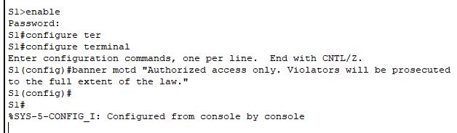
2. Which command do you issue to accomplish this step? 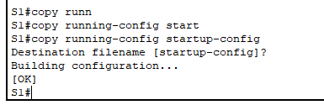
3. Click PC1, and then click the Desktop tab. Click IP Configuration. In the Addressing Table above, you can see that the IP address for PC1 is supposed to be 192.168.1.1 and the subnet mask 255.255.255.0. Enter this information for PC in the IP Configuration window. Repeat steps for PC2. 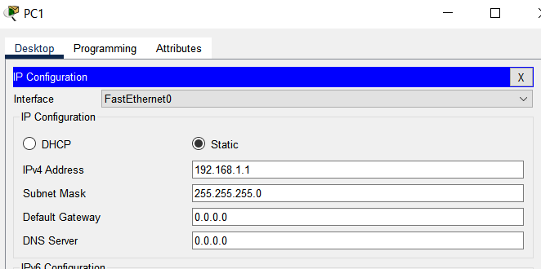

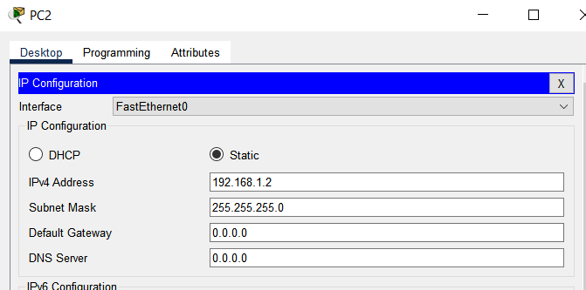

1. Click PC1. Close the IP Configuration window if it is still open. In the Desktop tab, click Command Prompt. Type the **ping**command and the IP address for S1, and press **Enter**.

**Answer: It should not be successful because the switches have not been configured with an IP address.** 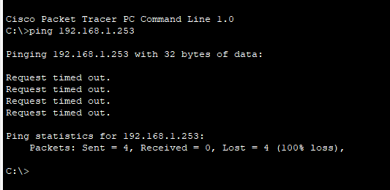

1. Switches can be used without any configurations. Switches forward information from one port to another based on Media Access Control (MAC) addresses.  An IP address is required to connect to a switch remotely. The switch is managed through VLAN1 by default. Why do you enter the no shutdown command?

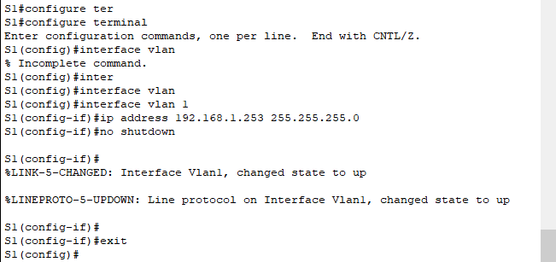

The no shutdown command administratively enables the interface to an active state.

1. Verify the IP address configuration on S1.

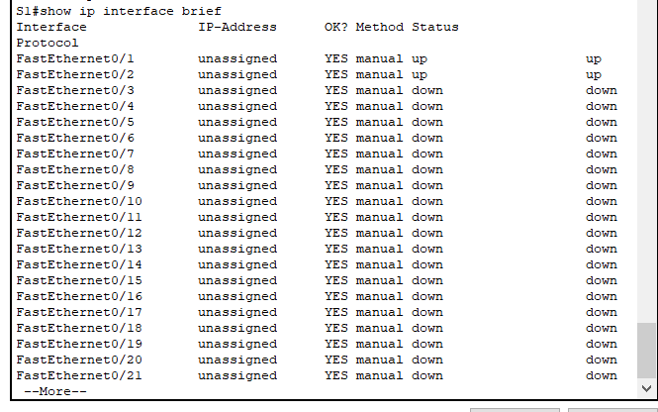

1. Saving the configuration

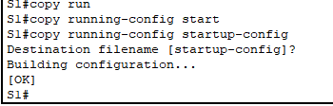

1. Verify the IP address configuration on S2.

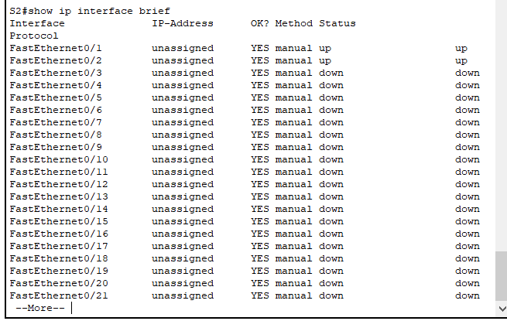

1. Saving the configuration

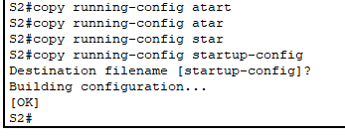

1. Which command is used to save the configuration file in RAM to NVRAM?

**“copy running-config startup-config command”**

1. Click PC1, and then click the Desktop tab. Open the Command Prompt.
   1. Ping the IP address for PC2.
   2. Ping the IP address for S1.
   3. Ping the IP address for S2.

